1.Top 15 Cuisines by Average Rating

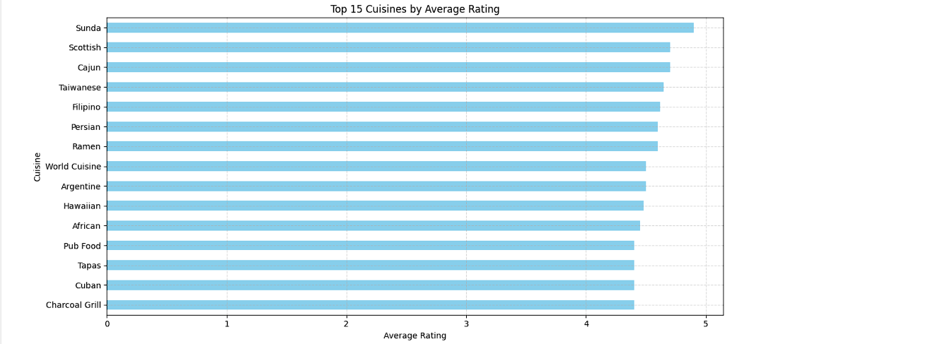

2. Top 15 Most Popular Cuisines by Total Votes

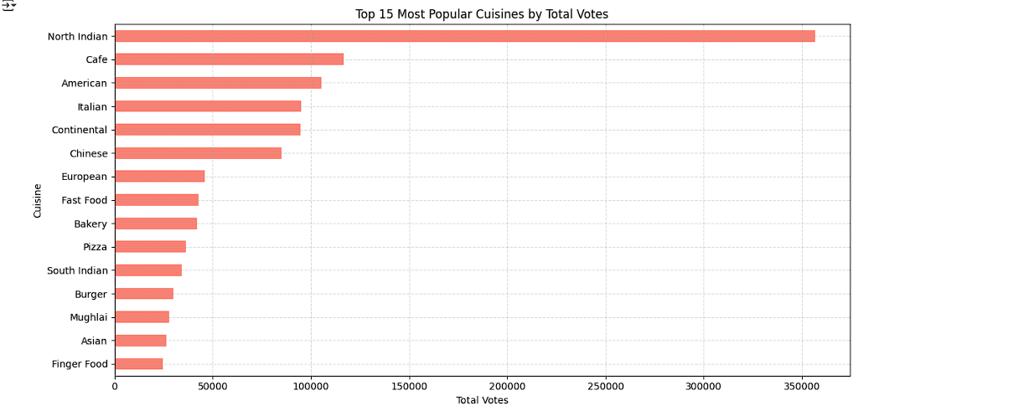

3. Votes vs Average Rating (Cuisines with > 50 Votes)
